Screenshots of bugs found.

Screenshots of bugs found were attached.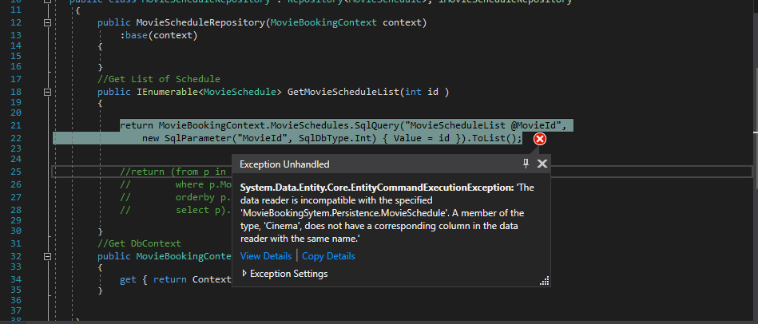

**Error:** System.Data.Entity.Core.EntityCommantExecutionException: “The data reader is incompatible with the specified ‘MovieBookingSystem.Persistence.MovieSchedule’. A member of the type, ‘Cinema’, does not have a corresponding column in the data reader with the same name.l

**Solution:** Altered the field from the source data which is a stored procedure, put a Cinema alias to fieldname c.Name resulting to c.Name as Cinema as highlighted below so that it will matched to property use in the schedule class/object.

alter PROCEDURE MovieScheduleList

(

@MovieId int

)

AS

BEGIN

if @MovieId>0

begin

Select a.MovieId,a.CinemaId,a.TakenSeats,a.Id,

**c.Name as Cinema**,a.DateFrom,a.DateTo, a.TimeFrom,a.TimeTo ,a.Price,a.RowLetter ,a.SeatPerRow

from MovieSchedules a INNER JOIN Movies b ON a.MovieId=b.Id INNER JOIN Cinemas c ON a.CinemaId=c.Id WHERE b.Id=@MovieId

end

END

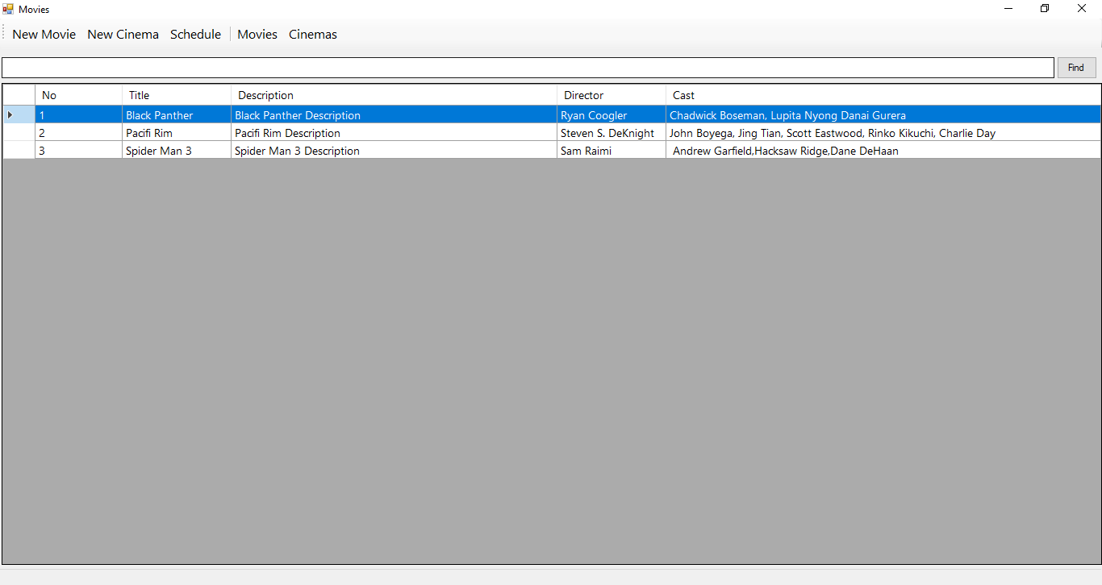

**Error:** Supposedly, it be able to search by title, by director, by cast from the movie table, but only search by title.

**Solution:** Created a stored procedure and use it for searching, that should concatenate the fieldnames title, description, director and cast and use it in the where clause as shown below:

create PROCEDURE MoviesListGet

(

@keyword nvarchar(100)

)

AS

BEGIN

if @keyword='' begin

Select * from Movies order by Title

end

else begin

Select * from Movies where Title + ' ' + Director + ' ' + Casts like '%'+@keyword+'%' order by Title

end

END

